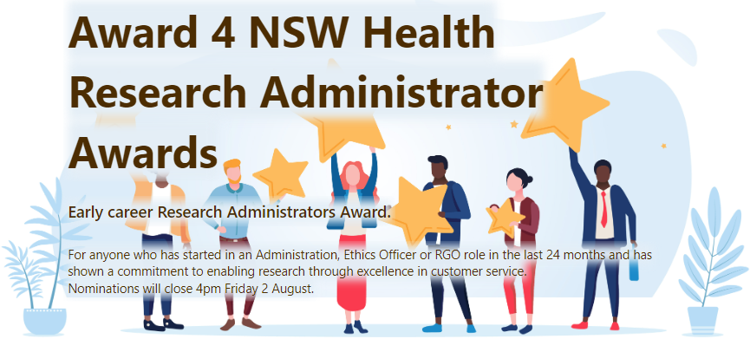

Early career Research Administrators Award
Research Office Managers are invited to submit a nomination for anyone who has started in an Administration, Ethics Officer or RGO (or equivalent) role in the last 24 months and has shown a commitment to enabling research through excellence in customer service.
Submissions will be presented to a small committee consisting of REGU and Research Operation Managers who
will vote on the winner.
Nominations close 4pm Friday 2 August

- Who would you like to nominate to be considered for the Early career Research Administrators Award in 2024?

- Please provide examples and justification for why this person should be considered for this award.

- Upload any supporting documents.

- Please type your first name and LHD/SHN/AHO you work (this is for voting validation and will not be shared)

Return this nomination form and supporting document to ehnsw-regis@health.nsw.gov.au

