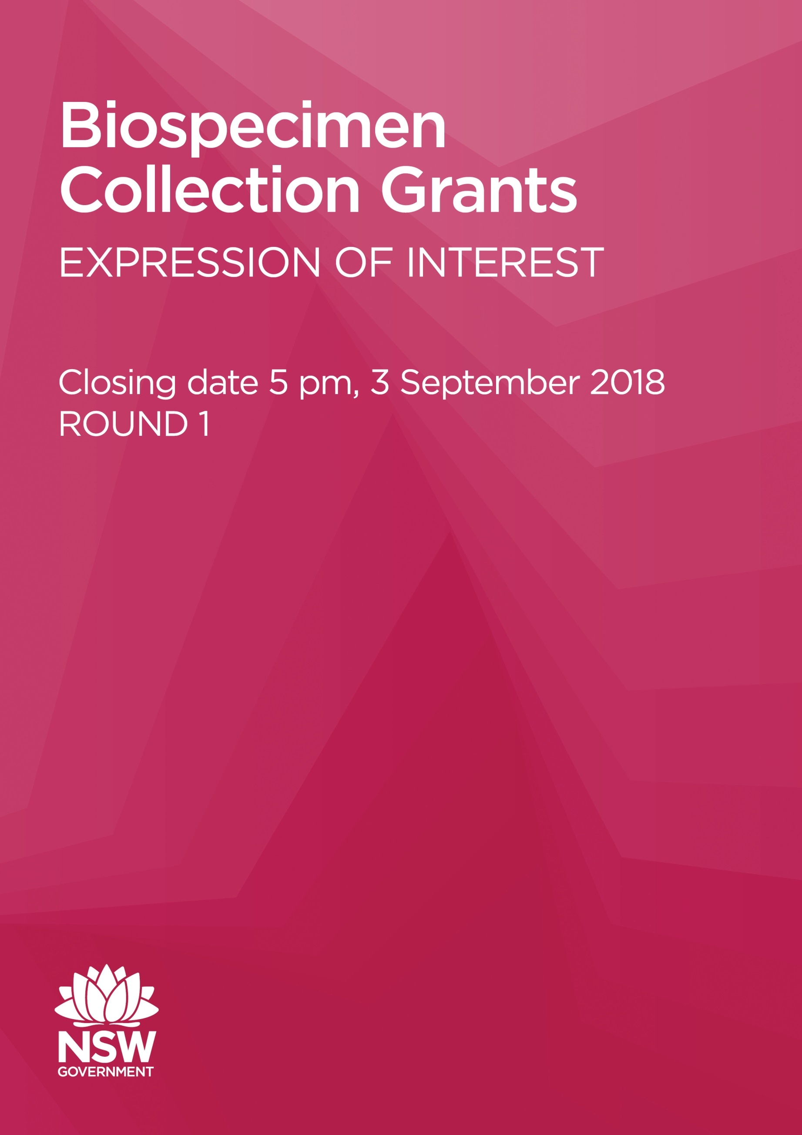
FURTHER INFORMATION
For further information on Biospecimen Collection Grants contact the Office for Health and Medical Research at: MOH-BiospecimenCollectionGrants@moh.health.nsw.gov.au

For queries regarding biobanking services available at the NSW Health Statewide Biobank contact 02 4920 4140 or NSWPATH-Biobanking@health.nsw.gov.au

For queries regarding data linkage services available from the Centre for Health Record Linkage contact 9391 9924 or cherel.mail@moh.health.nsw.gov.au
BIOSPECIMEN COLLECTION GRANTS – ROUND 1

NSW Health has developed the Biospecimen Collection Grants to support the development of collections of high quality biospecimens and associated data. The aim is to provide a research asset to the state that future researchers can use for the benefit of individuals and the NSW population and beyond, and to support research on priority health issues affecting the NSW population.

The biospecimens, from NSW people, will be collected, processed and stored in the NSW Health Statewide Biobank (NSWHSB) using a standardised approach. Through these grants, NSWHSB services will be funded for biospecimen collection, processing and storage. The Centre for Health Record Linkage (CHeReL), a dedicated data linkage centre within NSW Health, will be funded to support linkage of the biospecimens to NSW Health data collections, subject to feasibility assessment.

The Biospecimen Collection Grants will support collections that are:
a) Existing – that may require further biospecimen collection or storage
b) Prospective – new collections for which biospecimen collection has not yet started.
EOI applications will need to demonstrate the utility of the collection for future research.

NSW Health invites Expressions Of Interest (EOI) from investigators/managers of existing or new biospecimen collections from the following NSW entities:
- Universities
- Independent medical research institutes
- Public and private health system
- Non-profit organisations undertaking or supporting health and medical research

to apply for funding under the Biospecimen Collection Grants.

The Application process involves two stages:
- Stage 1: this EOI – to assess the strategic purpose of the proposed collection including:
  - how it addresses a priority health issue of NSW
  - utility as a research asset for NSW
  - how it leverages existing assets in NSW
  - uniqueness
  - relevant expertise of team
  - collaborations with researchers

- Stage 2: a Full Application – application to the NSWHSB and CHeReL to assess the collection:
  - quality,
  - governance,
  - consent,
  - sustainability, and
  - technical feasibility of collection and data linkage.

FUNDING DETAILS
Grants ranging from $20,000 to $100,000, over four years, are available. Individual grants will be capped at a maximum of $100,000.

If successful, applicants will be able to use the grant funding for up to four years, for:
- biospecimen collection, transport to NSWHSB, receipt, processing, storage
- biospecimen retrieval, dispatch and transport out of the NSWHSB within NSW
- storage of biospecimen related data

For information on pricing please refer to the NSWHSB service models and costs.

Successful applicants will also be covered for the following, outside of the grant:
- linkage of the collection to NSW Health data by the CHeReL for the period of this grant, including: access to routinely linked NSW Health data collections or other NSW Health data, subject to feasibility assessment, for the purpose of specific research projects; linkage to data collections managed by NSW Health for the purpose of administration (e.g. cancer verification).
- storage of the collection in the NSWHSB beyond the four year term of this grant, pending continued relevance and utility

Funding will be paid directly to NSWHSB and CHeReL for their services. For further detail on biospecimen and data-related components that the grant will fund, please see Appendix 1.

Applicants are encouraged to seek external funding sources to supplement any support received from the NSW Ministry of Health, including for research.

INSTRUCTIONS FOR SUBMITTING EXPRESSIONS OF INTEREST
The EOI must be submitted by 5pm, 3 September 2018 to:
MOH-BiospecimenCollectionGrants@moh.health.nsw.gov.au.

Applicants should submit this EOI Form and attachments in one PDF using the naming convention [RESEARCHER NAME] _BiospecimenCollectionGrant2018_ [DATE you emailed the document].

Applicants are encouraged to contact the NSWHSB and CHeReL before applying for this grant, see details on front page. After an initial EOI, there may be further discussion with applicants to clarify issues. Applicants will be provided feedback and given the opportunity to revise their applications.

PROCESS FOR REVIEW OF EOI
The EOI will be assessed by the NSWHSB Scientific Advisory Group. Applicants will be notified of the outcome of the review (ie. success or not to progress to stage 2) within six weeks of submission.

SUBMITTING A FULL APPLICATION FOR (STAGE 2)
The full application (Stage 2) includes:
- EOI (already completed)
- Application to NSWHSB and Centre for Health Record Linkage (CHeReL) for Collection or Access for an assessment of technical feasibility and service quote
- NSWHSB/CHeReL Letter of Support and service quote
- Budget

More details on timeframes will be released later.

GOVERNANCE OF COLLECTIONS
Governance of collections by the NSWHSB is articulated in the NSWHSB Collection Strategy.

ADMINISTRATIVE DETAILS

Collection Name
Principal Investigator Name
Including title
Principal Investigator
contact details
Mobile
Email
Address
Administering Institution Name
The organisation that will administer the funding

BIOSPECIMEN COLLECTION

- What type of collection does your Expression of Interest relate to?

- An existing collection ☐ Yes ☐ No

If existing, is the collection complete or are you still collecting biospecimens?

☐ complete ☐ still collecting

- A prospective collection ☐ Yes ☐ No

- In lay terms, briefly describe the collection that the grant will support?
(100 words maximum)

ELIGIBILITY CRITERIA

- Is at least 50% of your collection team based in NSW? | Yes☐  No☐
- Do you agree that the proposed collection will be stored at and distributed from NSWHSB if the grant application is successful (pending HREC approval)?  Collections under this grant must be stored at and distributed from the NSWHSB (see governance arrangements in NSWHSB Collection Strategy). | Yes☐  No☐
3a. If existing, is your collection open access now or do you agree to transition to open access within six months of receiving the grant (pending HREC approval)?  Collections under this grant must be open access within six months of receiving the grant (ie. biospecimens and data will be made available to all researchers in NSW subject to relevant approvals, at a minimum). | Yes☐  No☐
3b. If prospective, do you agree for your collection to be open access (pending HREC approval)?  Collections under this grant must be open access within six months of receiving the grant (ie. biospecimens and data will be made available to all researchers in NSW subject to relevant approvals, at a minimum). | Yes☐  No☐

Your collection must also satisfy NSWHSB eligibility criteria to bank biospecimens, available on the NSWHSB Collection Form. These include:
- Human Research Ethics Committee approval for the collection
- Verified ownership and governance arrangements - having a verified custodian and an approved Site Specific Assessment (if on a NSW Health Site), prior to the commencement of collection.
- Compliance with relevant legislation
- Compliance with the NSWHSB Consent Toolkit (full compliance for prospective collections and compliance with principles for existing collections).

STRATEGIC UTILITY OF THE COLLECTION

- How does or will this collection enable research on priority health issues of NSW?
(1 page maximum)

Comment on:
- What is/are the priority health issue/s of NSW that the collection addresses/will address?
- What platform of research is/could it support? What evidence gaps is/will/could it address? What research questions is/will/could it answer?
- What is the likelihood of this research having an impact on individuals and the population in NSW (ie. comment on the translatability of the research to practice)?

If your collection is existing provide letters of support from at least three researchers/research networks supporting your collection as a valuable asset.

- How is your collection unique in NSW, Australia and/or globally?

Have you explored the current NSW biobank market to determine the availability of any similar biospecimen collection?

☐ Yes ☐ No

If your collection is prospective, is a similar collection already available:

in any NSW Biobank? ☐ Yes ☐ No
in any Australian Biobank? ☐ Yes ☐ No

Specify how your collection is/will be unique and why any other existing collection/s of similar biospecimens is/will not be suitable for your purpose (200 words maximum).

- Does/will your collection leverage any existing assets or infrastructure in NSW (eg. 45 and Up)? How? (100 words maximum)

- Do you have any existing research proposals, using the collection, in the pipeline (ie. to the NHMRC or other funding bodies)? Or do you intend to submit any research proposals using the collection? (200 words maximum)
Comment on:
  - What stage are the/se proposal/s at?
  - What funding bodies are supporting the proposal/s or will you approach?
  - Whether you have HREC approval for the proposed research?
If drafted, please attach the research proposal/s (for reference only, not for review).

- For existing collections, has any research been completed? (200 words maximum)
Comment on:
  - Why is this research strategic?
  - What is the research?
  - What ongoing research could the existing collection support?

TEAM QUALITY AND CAPABILITY AND COLLABORATIONS

- Team quality and capability

At least 50% of the collection team must be based in NSW.

Title* | Name | Chief Investigator or Associate Investigator | Organisation | Located in NSW (Y/N) | Role | Relevant experience
*Please attach CV’s/biosketches (2-5 pages)

- Collection/research collaborators

Application must demonstrate or show potential for successful research collaboration or harnessing of significant research activity. Indicate whether partners are committed to ongoing engagement and support for the collection and help leverage any existing assets. For existing collections the researchers/research networks can be the same as for Strategic Utility: Question 1.

Title | Name | Chief Investigator or Associate Investigator | Organisation and Location | Role/asset leveraged | Relevant experience and track record of research and translation of research to practice | Any funding (in-kind or otherwise) sourced or confirmed

APPENDIX 1: Biospecimen and data-related components that the Biospecimen Collection Grants will fund

Grant will fund (for the period of the grant) | Paid directly to NSWHSB/  NSW Health Pathology  Pa  Pa | - biospecimen collection and transport from NSW Health Pathology (NSWHP) centres  - biospecimen receipt  - biospecimen processing  - DNA/RNA extraction  - biospecimen storage  - biospecimen access/retrieval and dispatch  - storage of and access to Biospecimen Related Data  - transport out of the NSWHSB within NSW via NSWHP Courier Service
NSW Health will fund outside the grant | Paid directly to NSWHP | - storage of the biospecimen and metadata beyond the period of the grant
NSW Health will fund outside the grant | Paid directly to NSWHP | - access to routinely linked NSW Health data collections⁴ or other NSW Health data, subject to feasibility assessment, for the purpose of specific research projects  - linkage to data collections managed by NSW Health for the purpose of administration (eg. cancer verification)
NSW Health will fund outside the grant | Paid directly to CHeReL
NSW Health will not fund |  | - biospecimen collection from centres other than NSWHP  - participant recruitment  - participant consenting  - value-add assays e.g. whole genome sequencing  - linkage to data collections not managed by NSW Health  - data related costs outside NSWHSB and CHeReL services  - transportation costs outside of NSWHP Courier Service  - ongoing biospecimen collection, transport, receipt and processing costs beyond the life of the grant.

Data or record linkage brings together information that relates to the same individual, family, place or event from different data sources or from different files.
Data directly associated with the biospecimen and includes: Biospecimen Meta-data (eg. biospecimen storage information) and Participant Data (name, address).
Data directly associated with the biospecimen and includes: Biospecimen Meta-data (eg. biospecimen storage information) and Participant Data (name, address). 4 Routinely linked data is shown at http://www.cherel.org.au/master-linkage-key. Access is subject to relevant HREC and data custodian approval

