

NSW Medical Devices Fund
Preliminary Application
2020-21
Round 8

General instructions
Preliminary Application Form and attachments
- Please answer the questions using the text boxes provided and limit responses to the stipulated word limit.
- Please complete the Business Canvas Model (BMC) which can be downloaded here: https://www.medicalresearch.nsw.gov.au/wp-content/uploads/2018/04/BMC-blank.pdf
- Please attach the BMC model in paper size A3 (maximum)) and font size 10 (minimum). Resources to understanding the BMC can be found in Appendix 1.
- Please only provide attachments listed in the application checklist, excess documentation will not be considered. Ensure that the declaration is signed by an authorised representative of the organisation/entity.
- Please ensure attachments do not have security protection and can easily be accessed.
- Please ensure all documents are submitted in PDF format (not Excel, PowerPoint, Word etc.)

Video
Please provide a three minute (max) video of describing the following and submit it with the application as a separate attachment, using .wmv format.
The video should include:
- The problem the device solves and for which patients (provide any clinical advice received)
- The market dynamics: market size, growth rates and key trends
- The specifics of the project for which funding is requested and how it will assist with commercialising the device
- The impact the device will have on the health system
- The proposed business model

How to submit your application
Please submit one copy of the application electronically in PDF format to
MOH-OHMRGrants@health.nsw.gov.au

Filenames must follow the naming convention of: ‘MDF2020_organisationname’ for preliminary applications and ‘MDF2020_organisationname_attachment’ for attachments.
Applicants must submit the application and video to the Office for Health and Medical Research
Videos submitted on a USB should be sent to:
Anne O’Neill
Director, Enterprise and International Partnerships
Office for Health and Medical Research
NSW Ministry of Health
100 Christie Street
ST LEONARDS NSW 2065

Application Checklist
☐ Completed Preliminary Application Form in PDF format only
☐ Completed Business Canvas Model attached
☐ Financial statements for FY2017/18 and FY2018/19 attached (if applicable)
☐ Balance Sheet and Profit and Loss statements for FY2017/18 and FY2018/19 (if applicable)
☐ Evidence of technical feasibility attached
☐ Evidence of clinical feasibility attached
☐ Evidence of IP Status attached
☐ Video attached OR USB posted (must be received by OHMR by the closing date)

Please provide the references to any relevant papers but do not include the entire paper. These will be requested if needed.

Indicative Program Timeline
Please note, dates are subject to change

Activity | Date
Call for Preliminary Applications | 25 November 2019
Preliminary Applications close | 3 February 2020
Sub Group meets | February 2020
Medical Devices Expert Panel meets | March 2020
Invitation to submit Full Application | April 2020
Full Applications close | May 2020
Medical Devices Expert Panel meets | May/June 2020
Invitation to present to Expert Panel | June/July 2020
Successful applicants notified | August 2020

Preliminary Application Form
Please list the name/s and administrative details of up to three key personnel on the team. This can include Directors, Founders and technological staff.
Key personnel 1 details
Title | First name | Last name | Position

Please indicate your gender
☐ Male ☐ Female ☐Other ☐Prefer not to say

Are you of Aboriginal and/ or Torres Strait Islander descent?
☐ No ☐ Yes ☐Prefer not to say

Do you reside in a Rural or Remote location (i.e. primarily work and reside outside the Sydney Metropolitan Area)?

☐ No ☐ Yes ☐Prefer not to say

Key personnel 2 details
Title | First name | Last name | Position

Please indicate your gender
☐ Male ☐ Female ☐Other ☐Prefer not to say

Are you of Aboriginal and/ or Torres Strait Islander descent?
☐ No ☐ Yes ☐Prefer not to say

Do you reside in a Rural or Remote location (i.e. primarily work and reside outside the Sydney Metropolitan Area)?

☐ No ☐ Yes ☐Prefer not to say
Key personnel 3 details
Title | First name | Last name | Position

Please indicate your gender
☐ Male ☐ Female ☐Other ☐Prefer not to say

Are you of Aboriginal and/ or Torres Strait Islander descent?
☐ No ☐ Yes ☐Prefer not to say

Do you reside in a Rural or Remote location (i.e. primarily work and reside outside the Sydney Metropolitan Area)?

☐ No ☐ Yes ☐Prefer not to say

Overview
Summary of device
Briefly describe the device in lay terms and explain how the device will impact the health system Please attach a high resolution image of the device in jpg format. (500 words max)

Applicant details
Name of organisation/entity applying for funding
If applicable, when was the entity incorporated?
Is the entity a subsidiary?
Is the entity headquartered in NSW? | Please include street address details
Who are the Directors?
Company website (if applicable)

Project details
Project title
Amount of funding requested
Target health or disease area the technology addresses
If successful, how will this grant help progress the development of this device? (100 words max)

From the TGA’s perspective what Class of Medical Device is it? Class 1, 2 or 3? | If not strictly a device what regulatory approvals will be required?
What stage of development is the device at (design, preclinical or clinical)?

Intellectual property
Provide a list of patents filed

Has the IP been licensed from elsewhere? | If yes, please provide details
List any other IP rights

Financial details
Provide details of any outstanding loans

Does cash at hand exceed all liabilities?

What equity finance has been raised to date? How much and from whom?

What grants have been raised to date? How much and from whom?

Please include a high level summary cash flow for the company for the next 3 years (main uses of cash, any income)

Previous submissions to MDF
Has the applicant applied to MDF before? | Please include year/s and project titles
If the applicant has previously received a MDF grant, is it completed? | If so, when? If not, which milestones have not been completed?
If unsuccessful previously, does this application clearly address the issues raised? | Please provide details

Section 1: Medical Device
- What is the scientific/technological basis of the device? (150 words max)

- Describe how the level of innovation in the device will create a compelling case for change in the target market (200 words max)

- Complete the following Technology Readiness Level Scale to indicate the current development stage of the device and the expected development stage if successful in obtaining funding from the MDF.
Refer to Appendix 2 for more information on the Technology Readiness Level Scale
Technology Readiness Level | 1 | 2 | 3 | 4 | 5 | 6 | 7 | 8 | 9
Now | ☐ | ☐ | ☐ | ☐ | ☐ | ☐ | ☐ | ☐ | ☐
At project end | ☐ | ☐ | ☐ | ☐ | ☐ | ☐ | ☐ | ☐ | ☐

- Describe the current stage of development of the device. Please provide evidence of the clinical, pre-clinical or bench-testing for the functionality, safety and efficacy of the device (200 words max)
Please note: copies of the studies may be requested in due course and should not be submitted as attachments at this stage.

- What are the key elements of the intellectual property portfolio (e.g. patents, trade secrets, trademarks, etc.) and what is the plan to build and protect this portfolio in key geographical target markets? (250 words max)
Please attach any evidence that supports the answer to this question.
- Has any Freedom To Operate work been undertaken on the Intellectual Property? (250 words max)

- What is the regulatory pathway for the device? Please include the device category, the regulatory requirements key geographical areas and the proposed timeframes (200 words max)

- Describe the stage of prototype development completed (150 words max)

Provide details of the stakeholders or groups of stakeholders who have been consulted (200 words max)

Section 2: Project
- What is the scope of the project and what are the top three project goals? Please include a simply quarterly gantt chart of the project timelines, deliverables and resources with a description of scope and estimated cost by quarter for the next two-three years (300 words max)

- What are the estimated total project timeline and costs? (150 words max)

- Estimated percentage of the project activities to be conducted in NSW
%

- Describe the key members of the project team, where they are based and their experience (200 words max)

- Provide details of developments currently taking place in this area both locally and internationally (200 words max)

Section 3: Health and Other Benefits

- Describe a typical patient who would use the device and indicate the size of the patient population in NSW, Australia and the world globally, currently and in 10 years (100 words max)

- Outline the clinical relevance of the device and the likely impact it will have on clinical practice in NSW, Australia and globally (250 words max)

- Briefly describe the impact that the device will have on the health system in NSW, Australia and globally (200 words max)

- Describe any other applications the device may have (150 words max)

Section 4: Commercial Case
- Please describe the business case for the product/service under the following headings (500 words max):
- What is the target customer segment(s) and what are their unmet needs?
- What is the value proposition you offer to give your customer segments a compelling reason to buy your product? How is it differentiated from the competition?
- How and how much will you charge for your product? Will there be any recurring revenues? Do you expect the product to be reimbursed?
- How will you market, sell and distribute the product to your target customers? E.g directly or through intermediaries
- What are the key capabilities the organisation has and needs to be successful? What key resources (people, infrastructure etc) will the organisation need?
- What will the cost structure of the organisation look like, and how will it generate a sustainable profit margin?
- How will the product/service be manufactured or provided?
- Are there any key external (industry, distributor, academic, manufacturing etc) relationships the organisation needs to develop and maintain in order to be successful?

- If relevant, please complete the following:
 | FY2017/18 | FY2018/19 | FY2019/20  (forecast) | FY2020/21 (forecast)
Sales Revenue
Gross Profit
Operating Profit
Current Assets (on June 30)
Current Liability (on June 30)
Please attach the Balance Sheet and Profit and Loss statements for FY2017-18 and FY2018-19.

References
Provide details of two referees who can be contacted regarding the clinical relevance of your device.
Referee 1:
Name:
Position:
Organisation:
Phone Number (w):
Phone Number (m):
Email:
Referee 2:
Name:
Position:
Organisation:
Phone Number (w):
Phone Number (m):
Email:

Provide details of two professional references for each ‘key personnel’ listed on page 4 of this application form.
Name of Key Personnel 1 ________________________
Referee 1:
Name:
Position:
Organisation:
Phone Number (w):
Phone Number (m):
Email:
Relationship:
Referee 2:
Name:
Position:
Organisation:
Phone Number (w):
Phone Number (m):
Email:
Relationship:

Name of Key Personnel 2: ________________________
Referee 1:
Name:
Position:
Organisation:
Phone Number (w):
Phone Number (m):
Email:
Relationship:
Referee 2:
Name:
Position:
Organisation:
Phone Number (w):
Phone Number (m):
Email:
Relationship:

Name of Key Personnel 3: ________________________
Referee 1:
Name:
Position:
Organisation:
Phone Number (w):
Phone Number (m):
Email:
Relationship:
Referee 2:
Name:
Position:
Organisation:
Phone Number (w):
Phone Number (m):
Email:
Relationship:

CEO/Vice Chancellor/Director’s Declaration

In the last five years have any of the organisations owners, directors or associates related to the project been the subject of any or any pending:
(i) legal proceedings, including winding up or bankruptcy proceedings
(ii) insolvency administrations or investigations
(iii) research misconduct
(iiii) investigations by ICAC or any other public body, including findings of dishonest, unfair and unconscionable conduct.
If yes, please provide detail below: ____________________________________________________________________________________________________________________________________________________________________________________________________________________________________________________________________________________________________________________________________
_________________________________________________________________________________
I understand that providing the above details will not exclude the organisation from being considered for a MDF grant, however further information may be required should the Health Administration Corporation (HAC) choose to enter into a Funding Agreement.
The information provided in this declaration is true and correct. I understand that this application may be circulated to third parties as required by the secretariat or the MDF Expert Panel.
Position: _____________________________

Signature: ____________________________

Date: _______________________________

CEO/Vice Chancellor/Director’s Declaration

I ______________________________________ (Name of Director/CEO/Vice Chancellor or delegate) from ____________________________________________ (name of applicant organisation) declare that the information provided in this application form is true and correct. I understand that this application may be circulated to third parties as required by the secretariat or the MDF Expert Panel. I provide consent for the primary contact details and lay description of the device (non-commercial in confidence), along with a brief summary of the project to be forwarded to third parties so they may make contact if they can assist.
Position: _____________________________

Signature: ____________________________

Date: ________________________________

Appendix 1 – The Business Model Canvas
The Business Model Canvas (BMC) was developed by Alexander Osterwalder as a strategic tool to outline the nine segments which form the building blocks for the business model in one page. The right side of the BMC focuses on the customer while the left side focuses on the business.
Please download the blank BMC template below and submit it with your application.
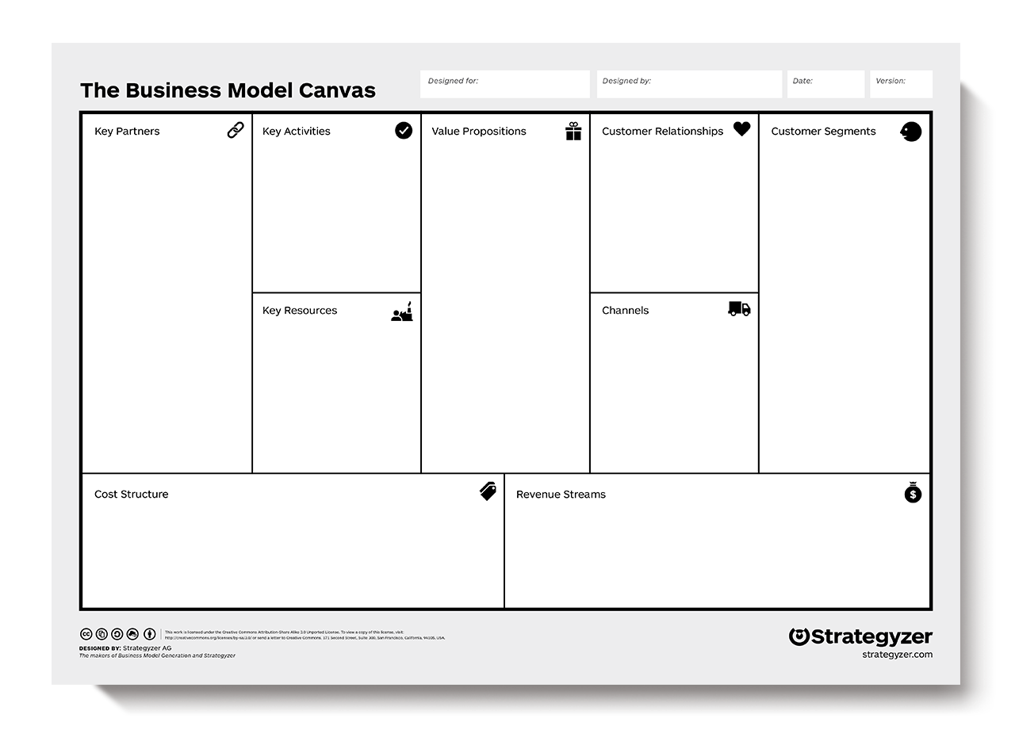

https://www.medicalresearch.nsw.gov.au/wp-content/uploads/2018/04/BMC-blank.pdf
Resources to understanding and completing the BMC can be found here:
- Business Model Canvas Tutorials:
https://canvanizer.com/how-to-use/business-model-canvas-tutorial

- Business Model Canvas for Startups:
https://www.youtube.com/watch?v=MxgqrDv7g0I

- How to Business Model Canvas explained:
https://medium.com/seed-digital/how-to-business-model-canvas-explained-ad3676b6fe4a

- How to use the Business Model Canvas:
https://www.businessmodelsinc.com/about-bmi/tools/business-model-canvas/

- Value Proposition Canvas Vest Practices:
https://www.youtube.com/watch?v=r0mtUQnny94

Appendix 2 – Technology Readiness Level Scale

TRL | TRL Description | Evidence of Achievement
1 | Basic principles observed and reported | Published research that identifies the principles that underlie this technology
2 | Technical Device concept formulated | Practical applications (e.g. devices) of the basic principles are invented
3 | Technical proof of concept demonstration | The basic performance of the invention is demonstrated in a laboratory setting
4 | Alpha prototype validation in laboratory environment | A simple prototype is developed and its performance is demonstrated in a laboratory environment. The performance indicates its potential for solving a clinical need
5 | Beta prototype validation in clinical environment | A more advanced prototype is developed and its performance is demonstrated in a clinical environment and further clinical feedback is gained for the final design phase
6 | Final Device design validation with clinical pilot study | The design of the device is frozen and a small number of devices are manufactured and a clinical pilot study is conducted by a key opinion leader. A pilot study report is prepared showing the results of the study
7 | Device from pilot manufacturing line is being clinically trialled in multiple geographical locations | A larger sample of devices are manufactured and sent to multiple clinical sites in different geographical locations for clinical trials. The reports from these trials will be used for submissions to regulatory authorities (e.g. TGA, CE, FDA)
8 | Device is partially approved and in clinical use | The device has been approved in limited geographical regions and is in clinical use in those regions
9 | Device is fully approved and in clinical use worldwide | The device is approved for use worldwide and is in clinical use worldwide

